

**The Polytechnic School**

Sutton Hall, Suite 140

6049 S Backus Mall

Mesa, AZ 85212

(480) 727-1177

Fax: (480) 727-2886

poly.engineering.asu.edu

**IFT 301 – Web Programming for Human Computer Interaction**

**Web Design Project – Project Update 1**

**Name: Brandon Trinkle**

**ASU ID: 1217455031**

**Date: 4/7/2024**

**Instructions:** You should have at least **two pages of your site and one CSS file completed** by the time you submit this assignment. Use the questions below to have a written discussion about the current progress of your web design project. After you answer the questions below, insert a screenshot of the pages you have completed so far as viewed in the browser. **Do NOT screenshot the HTML code.**

1. How do you feel your web design project is coming along?

My project is coming along very well, I am very happy with how the design is coming along. I have finished the first page, and will mimic the remaining pages to use the same style.

1. What issues have you encountered on your first few pages?

Most of my issues have been related to getting the website uploaded onto the local host. However, it is related with FileZilla, not the host website.

1. Describe where you would like to use a form on your website. Do you have any questions about creating this form?

I am using a form to collect customer information for my request quote option.

1. After doing several pages, has your sitemap changed? If so, revise your previous sitemap and insert it below.

I have changed the labels of the, but the content still remains the same.

1. Insert the browser view screenshot of page #1 here.

1. Insert the browser view screenshot of page #2 here.

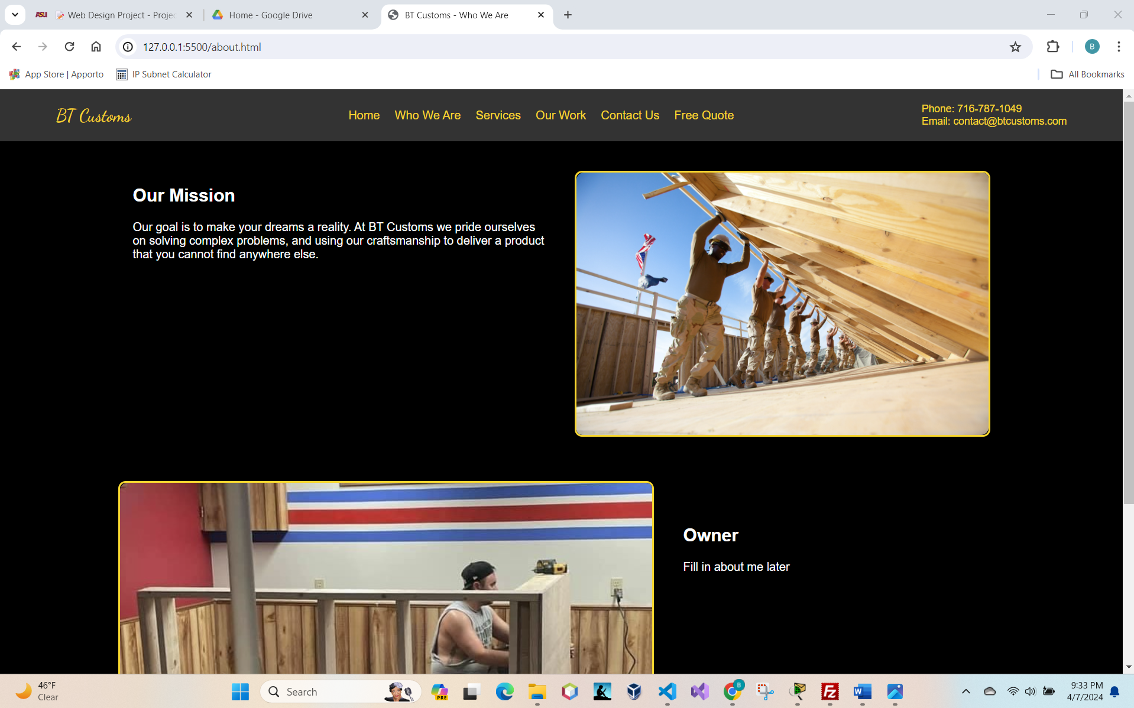

1. Copy and paste the text of your CSS file here.

/* General Styles */

body, html {

    background-color: black;

    color: white;

    font-family: Arial, sans-serif;

    margin: 0;

    padding: 0;

}

/* Header Styles */

header {

    align-items: center;

    background-color: #333;

    color: gold;

    display: flex;

    justify-content: space-between;

    padding: 10px 5%;

}

header .logo a,

nav ul li a {

    color: gold;

    text-decoration: none;

}

nav ul {

    display: flex;

    list-style: none;

}

nav ul li a {

    padding: 0 10px;

    transition: color 0.3s;

}

nav ul li a:hover {

    color: #d4af37;

}

.contact-info {

    color: gold;

    font-size: 14px;

}

.contact-info span {

    display: block;

}

/* Logo Text Style */

.honk-logo {

    font-family: "Dancing Script", cursive;

    font-optical-sizing: auto;

    font-size: 24px;

    font-style: normal;

    font-weight: normal;

}

/* Hero Styles */

.hero {

    color: rgb(9, 8, 0);

    position: relative;

    text-align: center;

}

.hero img {

    display: block;

    height: auto;

    max-height: 500px;

    object-fit: cover;

    width: 100%;

}

.hero-text {

    left: 50%;

    position: absolute;

    text-align: center;

    top: 50%;

    transform: translate(-50%, -50%);

}

.hero-text h1 {

    font-size: 50px;

    margin-bottom: 10px;

}

.hero-text p {

    font-size: 24px;

    margin-bottom: 20px;

}

/* Button Styles */

.btn {

    background-color: gold;

    color: black;

    display: inline-block;

    padding: 10px 20px;

    text-decoration: none;

    transition: background-color 0.3s;

}

.btn:hover {

    background-color: #d4af37;

}

/* Features Section */

.features {

    display: flex;

    flex-wrap: wrap;

    justify-content: space-around;

    margin: 20px 0;

}

.feature-box {

    background-color: #333;

    box-shadow: 0 2px 4px rgba(0, 0, 0, 0.2);

    margin: 10px;

    overflow: hidden;

    padding: 20px;

    text-align: center;

    width: 25%;

}

.feature-box img {

    display: block;

    height: auto;

    margin: 0 auto;

    max-width: 100%;

    perspective: 1000px;

}

.feature-box h3,

.feature-box p {

    color: gold;

}

/* Footer Styles */

footer {

    background-color: #333;

    color: gold;

    padding: 20px 0;

    text-align: center;

}

/* About Us Style */

.our-story-text {

    color: pink;

    font-family: 'Arial', sans-serif;

    font-size: 16px;

    line-height: 1.5;

    margin-bottom: 20px;

    text-align: justify;

}

#our-mission .container,

#our-story .container {

    align-items: flex-start;

    display: flex;

    flex-wrap: wrap;

    justify-content: space-between;

    margin: 0 auto;

    max-width: 1200px;

    padding: 20px;

}

#our-mission .text-section,

#our-mission .image-section,

#our-story .text-section {

    flex: 1;

    margin: 20px;

}

#our-story .text-section {

    padding: 20px;

}

#our-mission .image-section,

#our-story .image-section {

    position: relative;

    min-height: 200px;

}

#our-story .image-section img,

#our-mission .image-section img {

    border-radius: 10px 0;

    height: 100%;

    object-fit: cover;

    width: 100%;

}

/* Image Container Styles */

.image-container {

    display: inline-block;

    position: relative;

    overflow: hidden;

    border: 3px solid gold;

    border-radius: 10px;

    transition: transform 0.3s ease, box-shadow 0.3s ease;

}

.image-container img {

    display: block;

    width: auto;

    height: auto;

    object-fit: cover;

    transition: transform 0.3s ease;

}

/* Hover Effects */

.image-container:hover {

    transform: scale(1.05);

    box-shadow: 0 8px 15px rgba(0, 0, 0, 0.3);

.image-container:hover img {

    transform: scale(1.1);

}

/* Responsive Adjustments */

@media (max-width: 992px) {

    .feature-box {

        width: 45%;

    }

    #our-mission .container,

    #our-story .container {

        flex-direction: column;

    }

    #our-mission .text-section,

    #our-mission .image-section {

        max-width: 100%;

        margin: 10px 0;

    }

    #our-story .container {

        flex-direction: column-reverse;

    }

}

@media (max-width: 768px) {

    .feature-box {

        width: 100%;

    }

    nav ul {

        flex-direction: column;

    }

    nav ul li a {

        padding: 5px;

        text-align: center;

    }

    nav ul li a:hover {

        color: gold;

    }

}

@media (max-width: 768px) {

    .image-container {

        height: auto;

    }

}